Sligo ED Teaching and Quality Improvement Timetable Sep/Oct 2015

24 Sep  HAEMORRHAGE  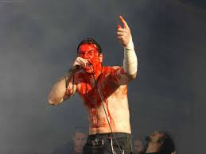 | Dr Zahalka:  Topic Review – NOACs and warfarin reversal  5 min topic: de Quervain’s Tenosynovitis (Flynn) | Dr Lee: Practical Session US guided peripheral vascular access | OSCEs  ECG of the Week
1 Oct | Dr Broderick: Guideline Review – Upper GI Haemorrhage  5 min topic: Scabies (Babikir) | Dr Hussain: Practical Session – Trauma Shock  FAST and Pelvic binders | Mr Hickey : ATLS Shock
8 Oct | Dr Flynn: Topic and practical session – Epistaxis- how to pack a nose  5 min topic: Impetigo (Zahalka) | Dr L Cunningham/ Dr O’Carroll: Simulation /Scenarios – Haemorrhagic shock | Podcast  X-ray of the Week
15 Oct | Dr Iftikhar/ Dr Lee: Morbidity +Mortality 17 Sep-14 Oct

Sligo ED Teaching and Quality Improvement Timetable Oct/Nov 2015
22 Oct  SEPSIS  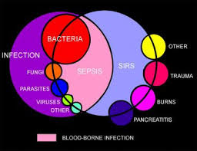 | Dr Bilal: Guideline Review -Sepsis 6  5 min topic: Stomatogingivitis in babies (Roemmele) | Dr L Cunningham: Practical Session – Blood cultures / Vascular port access | Journal Club  X-ray of the Week
29 Oct | Dr Med2: Topic review – Malaria  5 min topic: Nail trephining (Iftikhar) | Dr Hussain: Practical Session – Lumbar puncture | Podcast  ECG of the Week
5 Nov | Dr Flynn: Topic Review – Human/Animal Bites  5 min topic: The Bends (Bilal) | Dr L Cunningham: Simulation – Sepsis + Septic Shock | Podcast  X-ray of the Week
12 Nov | Dr Med1: Topic Review – Mumps/ Measles/ Varicella and their complications  5 min topic: Skin complications of IBD(Med2) | OSCEs – Dr Lee : Haemorrhage + Sepsis  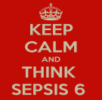
19 Nov | Dr Zahalka/ Dr Hussain: Morbidity +Mortality 15 Oct-18 Nov

