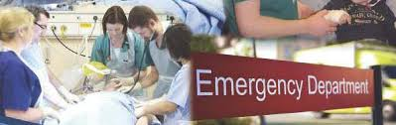

Emergency Medicine Trainees Teaching
Date | Recent trials update | Ultrasound | Regional Anaesthesia | Resuscitation and procedures | Top tips
20/7/16 |  |  | Ultrasound guided lower limb blocks |  | Nail bed repairs
27/7/16 | Sux v Roc in traumatic brain injury |  |  |  | Advanced ECG
3/8/16 |  | Locating foreign body with US |  | Paeds trauma
10/8/16 | After eighty trial |  |  | Difficult airway management

Wednesdays 1-2pm in the Seminar Room in ED
Schedule flexible – your suggestions are welcome

